**\*PRODUCT DESIGN THINKING**

**\*QUANTUM UNIVERSITY**

**\*ASS NO.3 (TASK 1)**

**\*Create a gap analysis for a product**

# **TASK 01**

# **Language Learning App - Gap Analysis & Design Thinking Approach**

## **Issue Observed**

Users of language learning apps often struggle with engagement, retention, and practical conversation skills.

## **Discussion**

Learners require interactive, immersive, and adaptive experiences to sustain motivation and achieve fluency. Many apps focus heavily on vocabulary and grammar but lack real-world application.

## **Solutions**

* AI-driven personalized learning paths
* Real-time conversation practice with AI tutors
* Gamification to enhance engagement
* Speech recognition for pronunciation feedback

# **Design Thinking Approach**

## **EMPATHIZE**

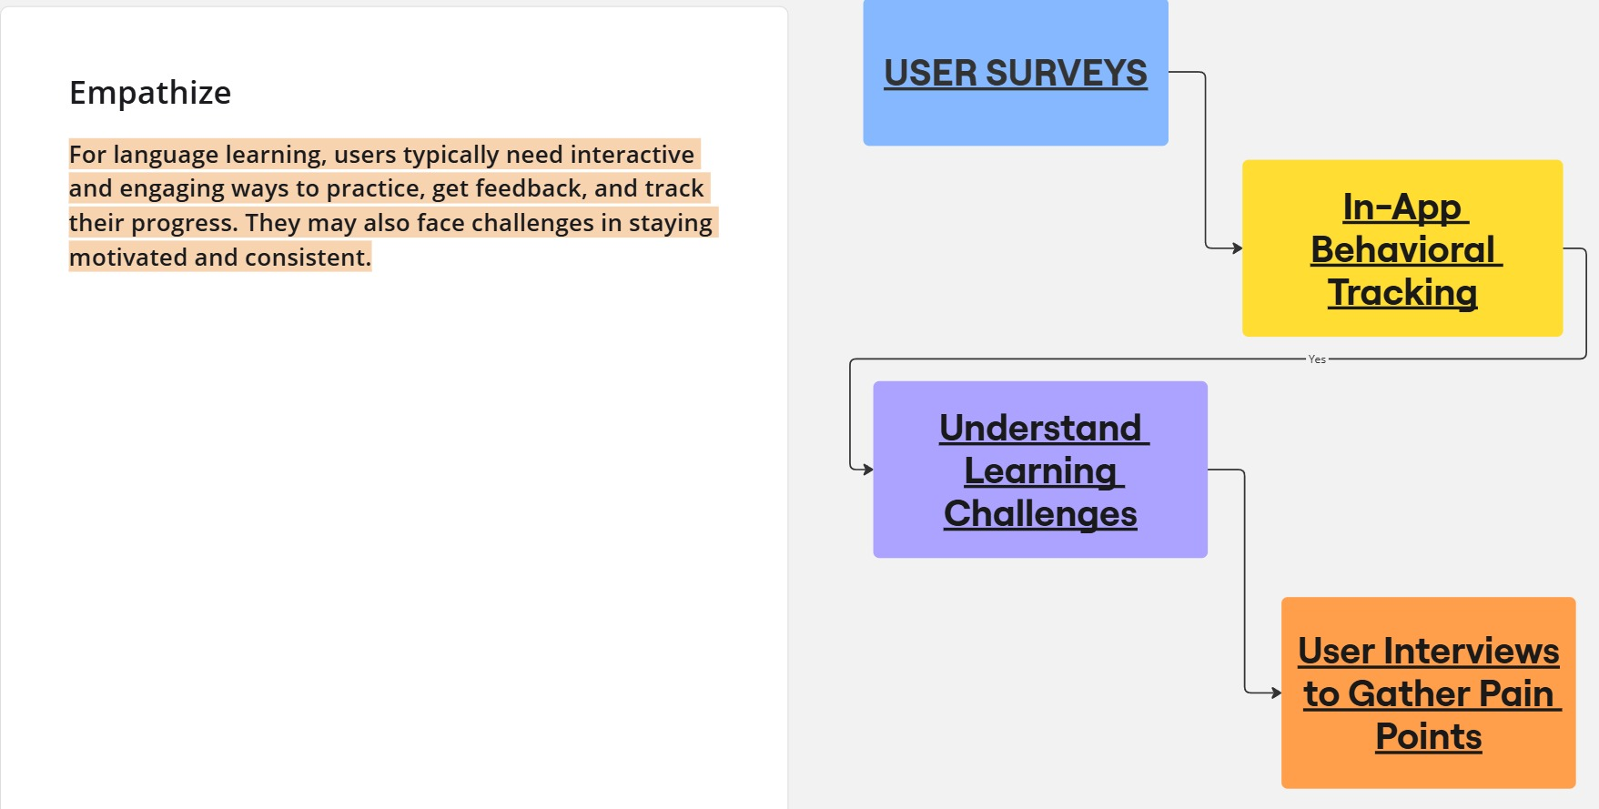

## **DEFINE**

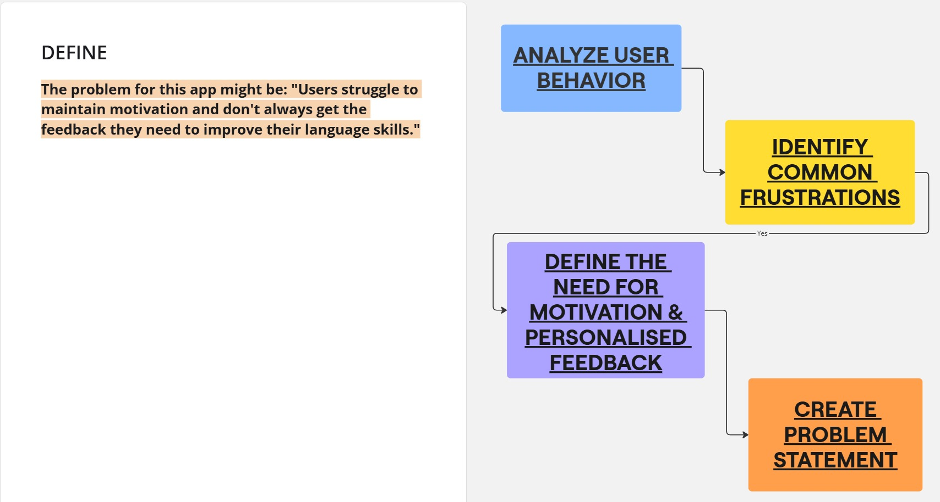

## **IDEATE**

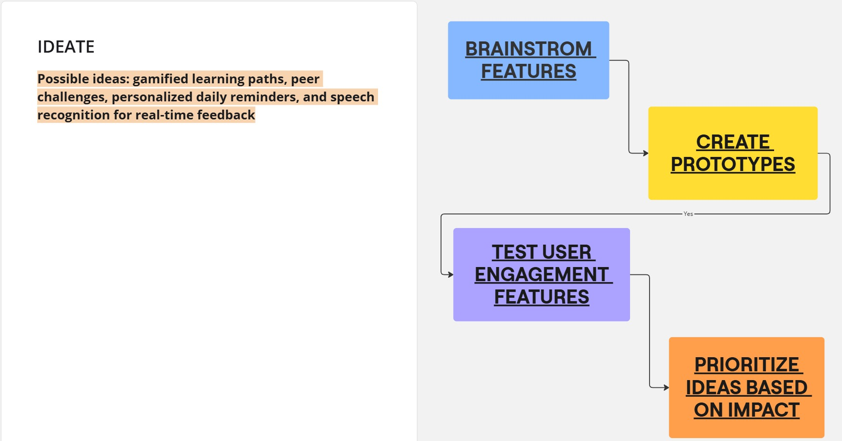

## **PROTOTYPE**

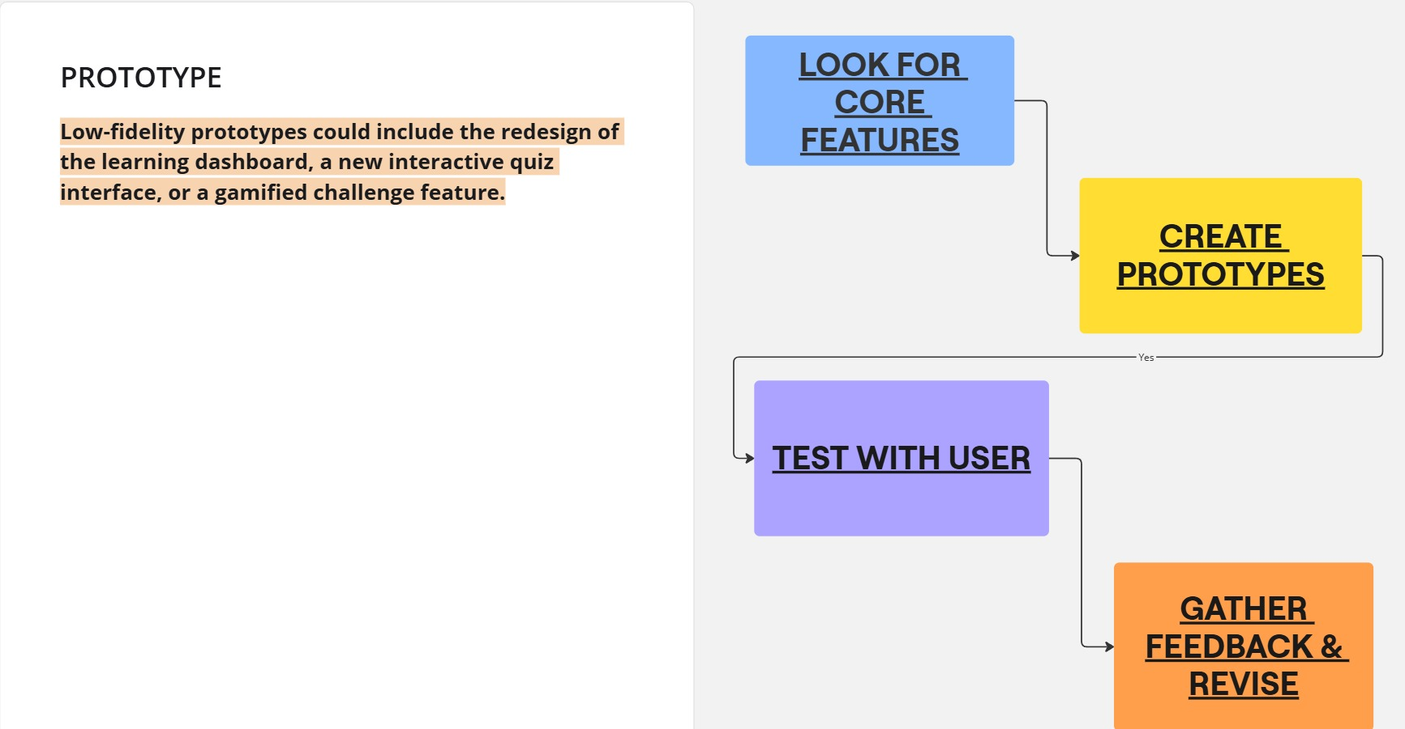

## **TEST**

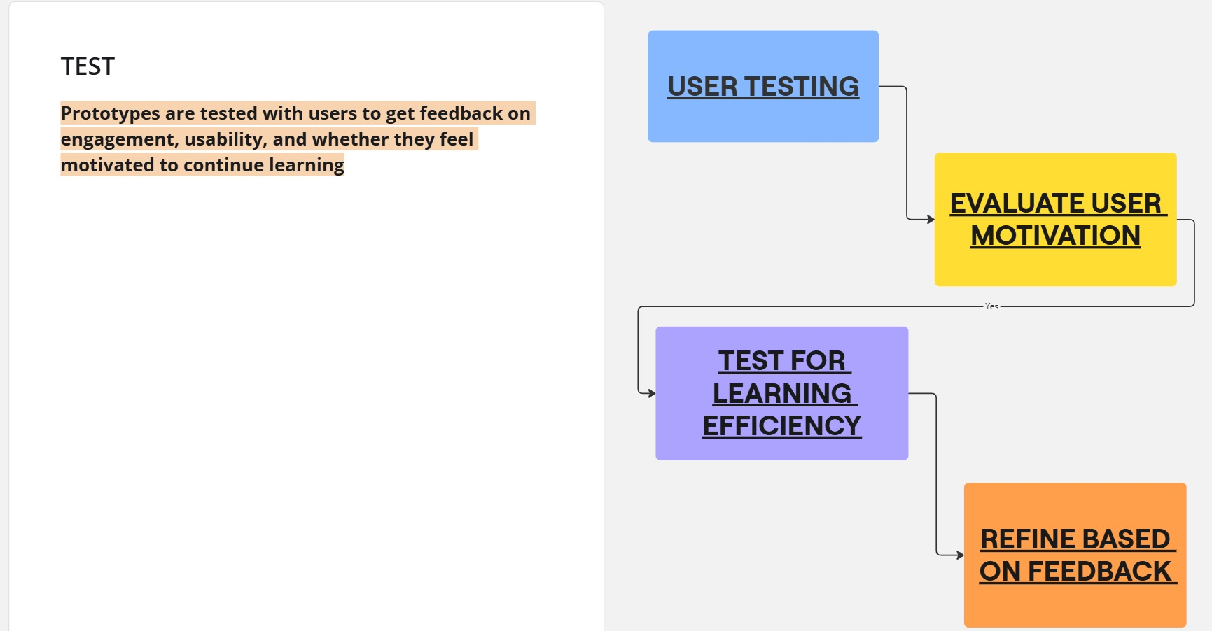

## **GAP ANYLSIS OF THE LEARNING APP**

|  |  |  |  |
| --- | --- | --- | --- |
| **Category** | **Current State** | **Desired State** | **Gap Identified** |
| **Personalization** | Standard lesson paths based on proficiency level. | AI-driven adaptive learning paths | Limited customization for user learning styles. |
| **Speaking Practice** | Pre-recorded dialogues with speech recognition. | Real-time conversation practice with AI or native speakers. | Lack of interactive speaking engagements. |
| **Engagement** | Gamification with points and streaks. | Immersive learning through AR/VR scenarios. | Traditional gamification methods feel repetitive. |
| **Feedback Mechanism** | Automated correctness feedback. | Detailed pronunciation and grammar suggestions. | Limited constructive feedback for improvement. |
| **Cultural Context** | Basic cultural notes in lessons. | Integrated real-world cultural exposure through media. | Insufficient real-life context for practical usage. |
| **Social Learning** | User forums and leaderboards. | Live group learning sessions and language exchange features. | Lack of peer interaction for collaborative learning. |